Kildare County Childcare Committee
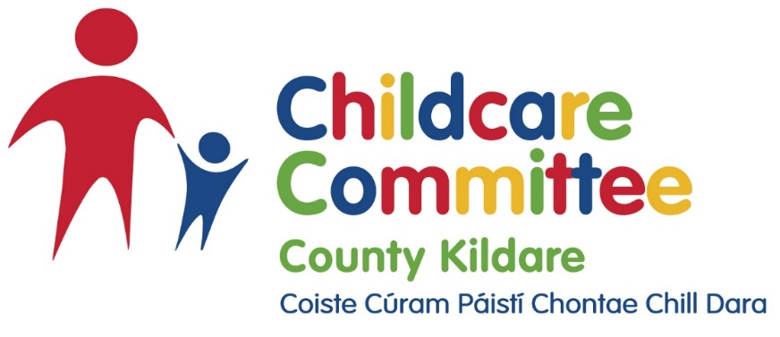

Applications are being sought from suitably qualified and experienced people for the role of

Regional Childminding Development Officer
Full-Time, Fixed term contract until 31st December 2022, this role may be extended subject to funding.
Closing date for the receipt of applications is Wednesday 16th March.
A full job specification and application form is available from www.kccc.ie
Candidates will be short listed based on information supplied in their Application Form.
Please send your completed application form, together with a covering letter to:
Louise Finnegan, info@kccc.ie
Interviews will be held (virtually) on 6th April 2022

