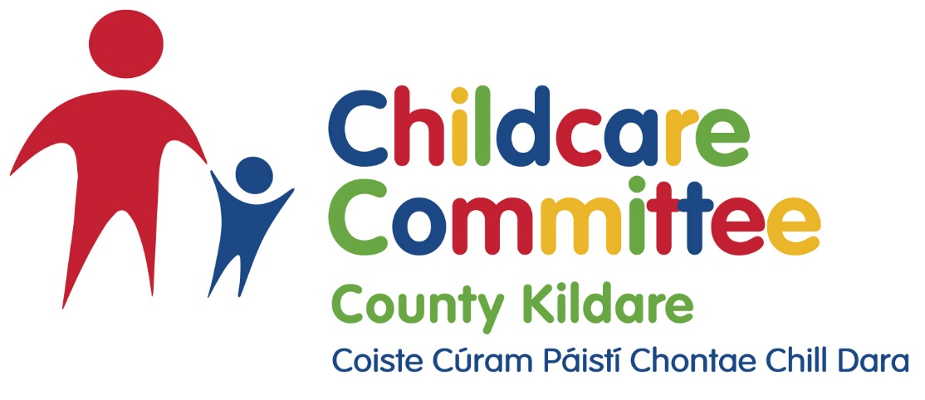

Job Description

Title: Regional Childminding Development Officer

Location: Kildare

Salary: Salary Scale Aligned to Local Authority Grade V (Point 1)

Childcare Committees supported: Westmeath, Meath, Louth, Longford, Offaly, Kildare

Purpose of the Role: This post will be a regional post based in the office of Kildare County Childcare Committee working with several Childcare Committees to support the development of the childminding sector and implementing actions as set out in the in the National Action Plan for Childminding (NAPC). This position will involve travel over the cluster region.

Professional Qualifications: Level 8 Qualification in Early Years Care and Education or equivalent

Experience: 5 years

The Role

The Childminding Development Officer will be employed by Kildare County Childcare Committee. Employment terms and conditions of the Childminding Development Officer will be determined by the employing CCC. The National CCC Childminding lead will oversee the implementation of work and will report to the DCEDIY.

- To work in collaboration with NAPC Advisory groups and National Coordinator to forward actions as set out in the National Action Plan for childminders.
- In Collaboration with the CCC’s, support the implementation of the National Action Plan for Childminding.
- Establish and develop effective working relationships and partnerships with the individual CCC childminding assigned contact persons
- Organise and participate in cluster meetings with assigned contact persons within CCC’s.
- In collaboration with the CCC’s, work with current and potential, childminders to deliver a high-quality early learning and care and/or school age service to meet the requirements of individual children, families and communities and to prepare for future regulatory requirements.
- Development of National Resources/training programmes.
- Delivery of training. Travel may be required over the cluster region.
- Support & implement the delivery of local information/resources and training events in cooperation with Cluster Area CCCs in relation to the National Action Plan for Childminders
- Support & implement other awareness-raising and networking activities in cooperation with Cluster Area CCCs in relation to the National Action Plan for Childminders
- In conjunction with the CCC, support the roll-out of existing and enhanced supports for childminders, including the Childminder Learner Fund, First Aid training, and Childminder Development Grants.
- Support the temporary continuation of the system of voluntary notification with CCCs in relation to eligibility for training opportunities and for funding such as the Childminder Development Grant, preparatory to the wider regulation of childminding.
- To identify and support the Tusla-registration of childminders who could potentially register within the current regulatory framework in partnership with the Cluster CCC’s.
- Carrying out such other tasks as may be required from time to time.
- To work in collaboration with NAPC Advisory groups and National Coordinator to forward actions as set out in the National Plan

The Person

Required:

A good understanding of Early Learning and Care (including Childminding) and the school age Childcare Sectors in relation to national policy and regulation.

Highly motivated and committed to working as part of a team as well as on own initiative.

Excellent interpersonal and communication skills both written and verbal with the ability to engage on an individual and group basis.

Excellent organisational skills, attention to detail and ability to solve problems.

Experience in organising and facilitating workshops.

Excellent IT and administrative skills, including experience in report writing and use of Microsoft Office Package including Word and Excel applications.
- Have a full clean driving licence.

Desirable:

Experience of working with the childminding sector and a good understanding of the policy context for childminding.

Experience in project management, including initiation, implementation and completion.

