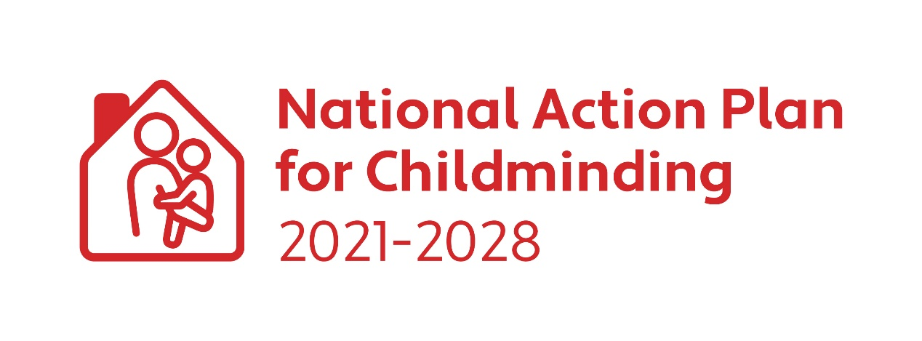CHILDMINDING DEVELOPMENT GRANT 2025

**Applicant Guidelines**

Closing Date for Applications: Friday 4 April 2025.



**Guidelines for Applicants/Childminders**

**What is a Childminder Development Capital Grant (CMDG)?**

The CMDG is a small capital grant designed to assist existing and potential childminders to enhance safety and quality in their childminding service. This includes eligible items required to meet regulations or that may have arisen during a pre-registration assessment.

**What funding is available under the CMDG?**

A grant of up to €1,000 is available to childminders. Childminders can apply for the full Childminding Development Grant amount every year, but only certain items may be purchased on an annual basis. (See eligible expenditure below and FAQ document). If the CMDG national budget is oversubscribed, an applicant may receive a lesser amount than applied for. **Successful applicants are paid 75% of the grant in advance, and up to the remaining 25% is paid in arrears. Following the submission and approval of the CMDG Expenditure Report and receipts for up to the full amount granted, the CCC will inform the successful childminder as to the balance up to 25% that will be paid. (See FAQs for further details)**.

**Restricted applications**

Childminders can apply for up to €1,000 annually. However, due to the expected lifespan of larger capital items, these cannot be purchased annually. Please see eligible expenditure list and FAQ document for further details.

**Who is eligible to apply for the funding?**

All existing or potential childminders.

**What supporting application documentation is required?**

* Fully completed application form.
* Evidence of appropriate childminding insurance. (Submit a copy of the schedule of insurance. Insurance must be in date at the time of application).
* Copy of Tusla Children First E-Learning Programme certificate (Must be dated within last 3 years).
* Current Tax Clearance Certificate (see FAQ for further details).

**What can the CMDG be used for?**

The CMDG can be used to purchase items that enhance safety and quality in the childminding service. The 2025 CMDG also includes provision for purchase of certain IT equipment, subject to conditions. The following list gives examples of the different types of costs that are eligible and ineligible for the grant. If you are unsure of eligible spend, contact your local City/County Childcare Committee for support.

**Eligible Spend**

|  |  |  |
| --- | --- | --- |
| **1** | **Outdoor Areas:** | Sand box; water tray; swing sets; slides; outdoor play equipment; natural outdoor surfacing such as grass or bark/mulch; outdoor fencing; drainage of outdoor areas; storage for outdoor equipment.  **Note:** Repeat applications for items with a long life span such as storage, and large play equipment such as swing sets, climbing frames, outdoor fencing etc. can only be made once every 5 years (see FAQ document for further details). |
| **2** | **Risky Play** | Climbable features such as crawling up and down ramps, wall-bars or a climbing wall; balance ropes with a handrail; stepping stones; timber structures.  Loose part materials to develop dens and huts e.g., boxes, sheets, and wooden planks etc.  **Note:** Repeat applications for items with a long life span such as wall bars, climbing walls and ramps can only be made once every 5 years (see FAQ document for further details). |
| 3 | **Gardening area** | Gardening materials e.g., plants, herbs, trees, shrubs, soil; materials for the development of flower and herb beds; rakes; shovels; wheelbarrow; watering cans; buckets; spades; gardening gloves etc.  **Note:** Most of the gardening equipment should be child sized. Equipment such as lawnmowers, hedge trimmers etc. will not be funded (see FAQ document for further details). |
| 4 | **Toys & Books** | Developmentally and culturally appropriate toys and books; ride on toys; building blocks; books; dress-up; teddys/dolls/figurines; music; imaginative play items; jigsaws; board games; arts & crafts materials and supplies etc. |
| 5 | **Childcare & Safety Equipment:** | Pram; buggy; car seats/booster seats; cot, mattress and linen, including foldable cots (see FAQs for further details); highchair and booster seats; stairgate; fire blanket; fire extinguishers; smoke alarms; carbon monoxide alarms; indoor storage; cupboard locks; first aid kit; blind cord safety clips; etc. |
| 6 | **Supporting Inclusion:** | Sensory toys & equipment e.g., black out tent, theraputty, chewlery, weighted blanket; trikes & ride on toys; fidget toys; move and sit cushions; supplies to create a sensory garden, etc. |
| 7 | **IT Equipment** | Funding is available for a **limited range** of small-scale IT equipment such as laptops, tablets, combined printer, copier, scanner to support Tusla registration and participation in e-Learning.  **Note 1:** The maximum grant for IT equipment is €500.  **Note 2:** Repeat applications for IT equipment can only be made once every 3 years (see FAQ document for further details).  **Note 3:** Refurbished items are allowable under the IT Equipment section. A receipt of purchase and proof of warranty will be required (see FAQ document for further details). |
| 8 | **STEAM Science/Technology/Engineering**  **/Arts/Mathematics):** | **Science :** Light box ; microscope; telescope; etc.  **Technology**: Coding Kits; robot kit; robotic arms; snap electric circuits; cameras; hydraulics; etc.  **Engineering**: Toolbox; stem construction kit; Lego; Lego technic; magnets, etc.  **Arts**: Music & Literature; musical instruments; easels; painting tools and accessories; playdough & accessories; arts and crafts supplies; speakers; lights, etc.  **Mathematics:** Magnet tiles; IQ puzzle games; mathematic games; Rubik’s cubes/tower; measuring equipment, etc. |
|  | **Other allowable expenditure** | Delivery costs  Specialist installation costs e.g., wired mains fire alarm/ ground works to install a shed/outdoor climbing frame, outdoor fencing, drainage of outdoor areas. |

**Ineligible Expenditure**

|  |
| --- |
| This is a list of examples of ineligible expenditure. If in any doubt, contact your local City/County Childcare Committee |
| * Minor adaptations or minor works to the house * Painting, decorating, flooring etc. * Redecorating playroom e.g., painting, flooring etc. * Adult-sized tables/chairs/couches for the house and/or playroom. * Dehumidifiers. * Specialist medical equipment such as defibrillators. * Trampolines; bouncy castles; above-ground swimming pools/framed swimming pools. * Outdoor safety mats/matting. * Electric outdoor toys such as electric cars. * Concreted areas. * Polytunnels. * Subscriptions; memberships and registrations. * Baby walkers. * Travel cots and/or travel cot mattress and travel sheets (see FAQs for further details). * Games consoles. * Second hand items (apart from refurbished IT items as per guidelines). * Insurance and/or other business expenses. * Training and Continuous Professional Development courses. * Any items that would be considered for mainly home use only e.g.   T.V, vacuum, air – fryer, water hose, cooking equipment, steam cleaners, bins. * Outdoor heaters. * Office equipment and consumables e.g. tables and chairs, printer ink etc. * Software for computers. |

**How to apply**

**It is recommended that you contact your local City/County Childcare Committee to discuss your application.**

* Please complete the application form using clear block writing.
* Please ensure all sections are complete.
* Ensure the application is signed.
* Forward evidence of insurance, tax clearance certification and your Tusla Children First eLearning programme certificate.
* Incomplete grant applications will not be processed i.e. all sections of the application form must be completed, and all required documents submitted.

**Post application information**

* Kildare County Childcare Committee will acknowledge receipt of an application.
* Successful applicants will receive correspondence from Kildare County Childcare Committee with the grant agreement plus any conditions of funding. Details of payment timelines will also be included.
* Unsuccessful applicants will receive correspondence informing them of the outcome of their application.
* Upon receipt of the signed grant agreement, and in line with payment timelines, Kildare County Childcare Committee will issue a payment of 75% of the total approved grant to each successful applicant.
* Applicants must spend 100% of the grant approval, or a lesser amount if the full award is no longer required, between Monday 19 May 2025 and Friday 3 October 2025.
* Eligible expenditure is between Monday 19 May 2025 and Friday 3 October 2025. **Any expenditure outside of this period will be deemed ineligible.**
* All successful applicants are required to complete a CMDG Expenditure Report after spending the full grant, or the amount required. The final deadline for submission of this report is Friday 17 October 2025.
* All successful applicants must submit their CMDG Expenditure Report and a copy of receipts for the full grant awarded, or the amount spent if less than the full award, to Kildare County Childcare Committee for appraisal. The final balance is awarded once 100% of the approved grant is spent.
* The applicant must agree to continue to provide a childminding service for at least 12 months following award of the grant.
* Potential childminders must begin childminding by 1 September 2025
* Successful applicants are not required to spend the full grant awarded e.g. if items are no longer available, or you have sourced cheaper product(s). The expenditure report should reflect your actual spend and any remaining grant fund can be returned to Kildare County Childcare Committee (see below).

**Unspent/Ineligible funding Procedure**

* Any unspent funds from the first 75% awarded, must be returned to Kildare County Childcare Committee.
* If Kildare County Childcare Committee deem any items as ineligible, they will calculate the final balance payment, and follow the process laid out below:

1. If the ineligible spend is less than 25%, Kildare County Childcare Committee will recoup the funds from the remaining 25% and pay the balance to the applicant.
2. If the ineligible spend represents more than the remaining 25% of the grant, Kildare County Childcare Committee will retain the 25% and the applicant will be required to repay the balance.

* Any successful applicant who does not repay ineligible expenditure will be unable to apply for future CMDG grants until such time as the outstanding funding is repaid. Any outstanding ineligible expenditure will be recouped from any future childcare programme funding awarded or other childcare grant programmes.
* Any successful applicant who does not return an expenditure report, will be liable for the full repayment of any grant awarded. Failure to repay outstanding amounts will result in the applicant being unable to apply for future CMDG grants until such time as the outstanding funding is repaid. Any outstanding ineligible expenditure will be recouped from any future childcare programme funding awarded or other childcare grant programmes.
* If a successful applicant ceases/does not begin childminding by 1 September, Kildare County Childcare Committee will take the necessary steps to recoup the funding in accordance with terms and conditions set out in these guidelines.

**Appeals**

* Appeals are only permitted where the applicant disagrees with the final ineligible expenditure decision, reached through the appraisal of the applicant’s expenditure report.
* An appeal can lodged, in writing by email, with Kildare County Childcare Committee up to 5 working days after receipt of the final email confirming the balance of the grant awarded.
* The appeal should set out why the applicant disagrees with the eligibility decision. Additional documentation that was not submitted with the expenditure report will not be taken into consideration at the appeal stage.
* The Appeals Committee is made up of a Kildare County Childcare Committee Representative and a DCEDIY representative.
* All documents concerned with the appeals process will be kept on file.
* The result of the appeal will be communicated to the applicant within 10 days of receipt of the appeal.

**Oversubscription Procedure:**

If the CMDG funding is oversubscribed all successful applicants will receive an equal percentage of the grant amount applied for on their CMDG application. This percentage will be determined by the reduction required to bring the CMDG national total down to the funding level available.

**Important dates**

|  |  |
| --- | --- |
| Tuesday 4 February | Launch of Childminding Development Grants |
| Friday 4 April | Closing date for applications |
| Week beginning Monday 19 May | Approval letters begin to issue |
| Monday 19 May – Friday 3 October | Expenditure window |
| Friday 17 October | Final submission date for expenditure reports and receipts |
| Week beginning Monday 10 November | Applicants informed of final balance/recoupment |

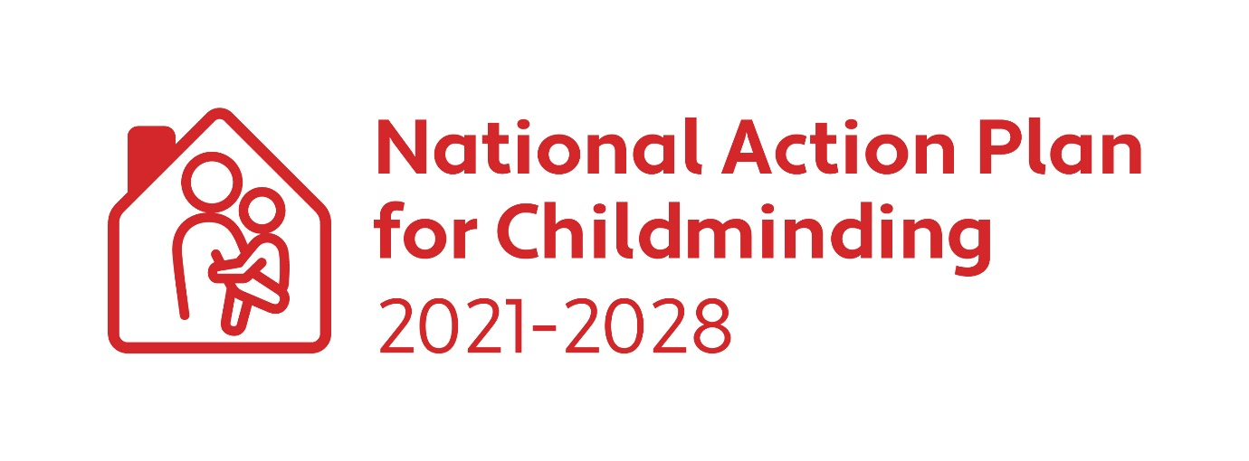**CHILDMINDING DEVELOPMENT GRANT 2025**

Application Form

**Closing Date for Applications: Friday 4 April 2025**



**Applicant Details:**

|  |  |
| --- | --- |
| Name of Applicant: |  |
| Childminding Business Name: (Optional) |  |
| Address of Applicant: |  |
|  |
|  |
| Mobile Telephone: |  |
| E-mail: |  |
| I am a Tusla Registered Childminder:  I am not registered with Tusla and am not yet required to register:  (*Childminders previously exempt from registration with Tusla are not required to register over the transitional period - the transitional period lasts from 30th September 2024 until end Sept 2027)*    I am planning to start being a Childminder in 2025: | |
| I declare that I do not have any previous convictions for any offence involving violence or harm to children/adults:  Yes | |
| Evidence of Childminding Insurance submitted:  Yes  Or  New/potential childminder  Yes  New/potential childminders must start childminding by 1 September and must submit a copy of childminding insurance at this time. | |
| Evidence of completion of Tusla Children First E-Learning Programme submitted:  Yes | |
| Current Tax Clearance Certificate submitted:  Yes | |

*By ticking this box, I agree to the retention of my contact details by the DCEDIY and Kildare County Childcare Committee for the purposes of sharing updates and engaging in consultation, relating to the implementation of the National Action Plan for Childminding 2021-2028:*

*You can withdraw your consent at any time by email to Kildare County Childcare Committee.*

**Please give a brief description of what you intend to spend the grant on (Max 200 words):**

|  |
| --- |
|  |

**State the total amount of grant you are applying for.**

|  |
| --- |
| **€** |

Please refer to Childminding Development Grant (CMDG) Applicant Guidelines for details of **eligible** and **ineligible spends**. Please contact Kildare County Childcare Committee to discuss your intended purchases to ensure that they will be eligible under the grant conditions.

**The grant will be paid into your bank account, please input your bank details here:**

**(Please use block capitals)**

|  |  |
| --- | --- |
| **Bank Details** |  |
| Account Name: |  |
| Payee Address: |  |
| IBAN: |  |
| BIC: |  |
| Bank Name: |  |
| Bank Address: |  |

|  |  |
| --- | --- |
| **Applicant Declaration:**  I understand and agree to the following terms and conditions:   * To comply with all the terms and conditions set out in the CMDG 2024 guidelines. * That I will receive correspondence from Kildare County Childcare Committee with the grant agreement plus any conditions of funding. * If my application for funding is successful, but the Childminding Development Grant national budget is oversubscribed, I may receive a lesser amount than I applied for. * That if I am unsuccessful, I will receive correspondence from Kildare County Childcare Committee setting out why my application has been refused. * Upon receipt of my signed grant agreement Kildare County Childcare Committee will issue 75% of the total grant approved to me according to the timeline set out in the approval letter. * I must submit my CMDG Expenditure Report and receipts and any other required documents to Kildare County Childcare Committee any time before Friday 17 October 2025.  **Failure to submit the CMDG Expenditure report and receipts will result in**  **Kildare County Childcare Committee implementing the unspent/ineligible funding guidelines.** * I understand that the grant money is not tax free. * I may receive a compliance visit. I will receive notice of such a visit, and I agree to provide reasonable assistance during such visit. * As an existing childminder, I agree to continue to provide a childminding service for at least 12 months following receipt of the grant. * As a potential childminder, I must begin childminding by 1 September. * Any unspent funds from the first 75% awarded must be returned to Kildare County Childcare Committee. * All or part of this grant may need to be returned if the expenditure has been deemed ineligible by Kildare County Childcare Committee . * Any failure of technology or disruption to internet services affecting submission of the application will be at my own risk and neither Kildare County Childcare Committee nor the DCEDIY accepts any liability if the full application fails to be submitted with supporting documentation or is rejected as a late submission. * I hereby give authorisation to Kildare County Childcare Committee to make an online payment transfer to my bank account. * The signed and returned grant agreement represent the contract between myself and Kildare County Childcare Committee . * I agree to indemnify Kildare County Childcare Committee , Pobal and the Exchequer from and against all actions, proceedings and costs, claims, demands and liabilities howsoever, arising from all and every action in connection with the approved grant. * I declare that the information provided is true and complete.   **Repayment of Grant Aid to**  **Kildare County Childcare Committee**  Kildare County Childcare Committee can cancel the grant, withhold any grant monies unpaid to date, and look for repayment of any monies that have already been paid to the successful applicant, if the successful applicant fails to comply with the terms of this agreement.  **Disclosure under the Freedom of Information**  Under the Freedom of Information Act 2014, the information in this document and its attachments may be released on request to third parties.  If you believe that any of the information in this document is sensitive and should not be disclosed to a third party, you must identify the sensitive information and provide the reason(s) for its sensitivity at the time of the application.  You will be consulted about the sensitive information before any decision is made to release the information to a third party. If you do not identify any of the information supplied in this document and supporting documentation as being sensitive you are acknowledging that any, or all of the information supplied, may be released in response to a Freedom of Information request.  Please outline the sensitive information and the reason(s) for the sensitivity below and submit with your application:   |  | | --- | |  |   **General Data Protection Regulations:**  All records and data will be processed in compliance with GDPR. Please see the [DCEDIY Privacy Notice](https://scanner.topsec.com/?d=296&r=show&u=https%3A%2F%2Fwww.gov.ie%2Fpdf%2F34511%2F%3Fpage%3D1&t=017af59dd6607ed8d8130525e744b16245d2be00) for further information.  Early Learning and Care Services and School Age Childcare Services must ensure that they are fully aware and comply with their obligations and responsibilities in relation to processing personal data within their service(s). Please refer to the Data Protection Commission for additional information in relation obligations in relation to GDPR. Here is a link to their website: [Data Protection Commission Guidance](https://www.dataprotection.ie/en/dpc-guidance)  The DCEDIY is the Data Controller for personal data processed for the CMDG. The DCEDIY privacy notice can be accessed at: <https://www.gov.ie/en/help/privacy-policy/>  Kildare County Childcare Committee /Pobal as Data Processors will process applications under the instructions of the DCEDIY. Your information will be processed in the following ways:   * Contact details and bank account information from the application form will be used for the payment process for this grant. * The information contained in your application form may be used for research purposes by the DCEDIY or Pobal in relation to the impact of this funding on the early years sector.   As part of the administration and management of this grant Kildare County Childcare Committee /DCEDIY and/or Pobal may share the information in this application form with other Departments, Statutory Bodies, or their agents.  **PLEASE NOTE:**  Late applications will not be accepted. Only complete application forms with the relevant supporting documentation will be processed. All application forms must be scanned or posted; photographs of application forms will not be accepted.  **Signature of Applicant**  By signing below, I confirm I have read, understand, and accept the terms and conditions outlined above in this Application & Declaration.  **Applicants Signature:** ________________________________  **Date:** ________________ |

**Please send your completed application form to Kildare County Childcare Committee by Friday 4 April 2025.**

Email address: rcmdo@kccc.ie (Please ensure documents are scanned to good quality)

Postal address:

**CMDO**

**Kildare County Childcare Committee**

Unit 21

Thompson Enterprise Centre

Clane Business Park

Clane

Co. Kildare

W91E6NY

|  |  |
| --- | --- |
| **Checklist for Applicant** |  |
| **Please tick when completed** | Applicant  Please tick |
| CMDG application form. Should be signed by applicant |  |
| Evidence of appropriate childminding schedule of insurance (Insurance must be in date at time of application).  New/potential childminders must start childminding by 1 September and must submit a copy of insurance at this time. |  |
| Copy of Tusla Children First E-Learning Programme Certificate (dated in the last 3 years) |  |
| Current Tax Clearance Certificate in applicants name |  |
| Tick the consent for the retention of contact details for the purposes of information sharing in relation to NAPC 2021-28  **Please Note: This is optional** |  |
| Bank details are complete and legible |  |
| Signed applicant declaration |  |
| Application form grant application is in line with the eligible spend as per the guidelines |  |