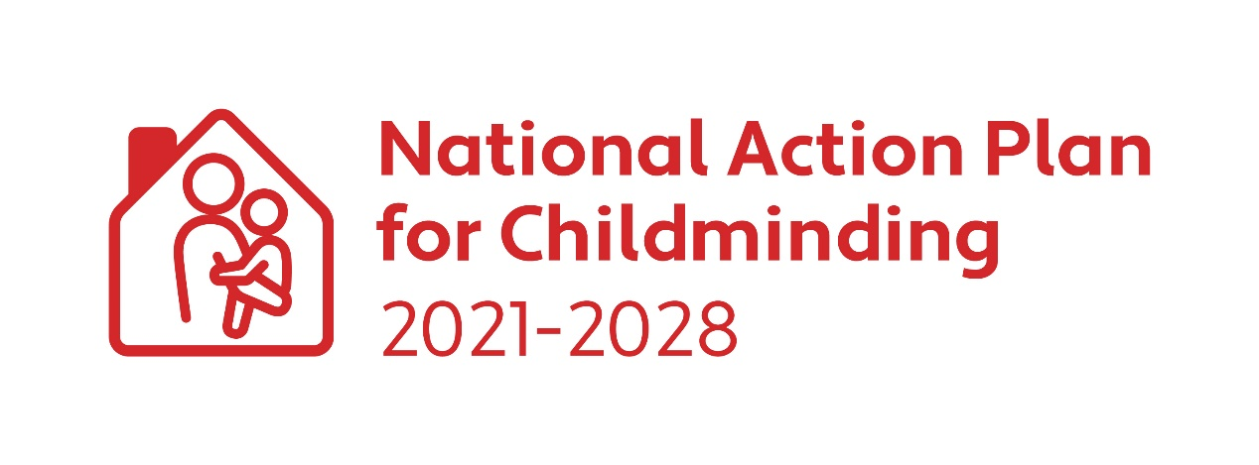CHILDMINDING DEVELOPMENT GRANT 2024

Applicant Guidelines

Closing Date for Applications: Friday 7 June 2024

Guidelines for Applicants/Childminders
What is a Childminder Development Capital Grant (CMDG)?
The CMDG is a small capital grant designed to assist existing and potential childminders to enhance safety and quality in their childminding service. The 2024 CMDG also includes an IT grant.

What funding is available under the CMDG?
A grant of up to €1,000 is available to eligible childminders annually. Childminders can apply for the full Childminding Development Grant amount every year however only certain items may be purchased on an annual basis. (See eligible expenditure below and FAQ document). If the CMDG national budget is oversubscribed, an applicant may receive a lesser amount than applied for. Successful applicants are paid 75% of the grant in advance, the applicant must spend 100% of the grant approved and the remaining 25% is paid in arrears. Following submission and approval of the CMDG Expenditure Report and receipts for the full amount granted, the remaining up to 25% is paid to the childminder.

Restricted applications
Childminders can apply for up to €1,000 annually. However, due to the expected lifespan of larger capital items, these cannot be purchased annually. Please see eligible expenditure list and FAQ document for further details.

Who is eligible to apply for the funding?
All existing or potential childminders. Where a Childminder is subject to the Child Care Act 1991 (Early Years Services) Regulations 2016 and (Early Years Services) (Registrations of School Age) Regulations 2018, the service must be registered with Tusla before applying.

What supporting information/documentation must be submitted with the application form?
- Fully completed application form.
- Evidence of appropriate childminding insurance. (Submit a copy of the schedule of insurance, insurance must be in date at the time of application).
- Copy of Tusla Children First E-Learning Programme certificate (Must be dated within last 3 years).
- Current Tax Clearance Certificate, dated within the year of application.

What can the CMDG be used for?
The CMDG can be used to purchase items that enhance safety and quality in the childminding service. The 2024 CMDG also includes provision for purchase of certain IT equipment, subject to conditions. The following list gives examples of the different types of costs that are eligible and ineligible for the grant. If you are unsure of eligible spend, contact your local City/County Childcare Committee for support.

Eligible Spend
1 | Outdoor Areas: | Sand box; water tray; swing sets, slides, outdoor play equipment, natural outdoor surfacing such as grass or bark/mulch, outdoor fencing, drainage of outdoor areas, storage for outdoor equipment.  Note: Repeat applications for items with a long life span such as storage, and large play equipment such as swing sets, climbing frames, outdoor fencing etc. can only be made once every 5 years (see FAQ document for further details).
2 | Risky Play | Climbable features such as crawling up and down ramps, wall-bars or a climbing wall, balance ropes with a handrail, stepping stones, low walls, timber structures.  Loose part materials to develop dens and huts e.g., boxes, sheets, and wooden planks etc.  Note: Repeat applications for items with a long lifespan such as wall bars, climbing walls and ramps can only be made once every 5 years (see FAQ document for further details).
3 | Gardening area | Gardening materials e.g., digging, plants, herbs, trees, shrubs, soil, materials for the development of flower and herb beds, rakes, shovels, wheelbarrow, watering cans, buckets, spades, gardening gloves etc.  Note: Most of the gardening equipment should be child sized. Equipment such as lawnmowers, hedge trimmers etc. will not be funded (see FAQ document for further details).
4 | Toys & Books | Developmentally and culturally appropriate toys and books e.g., ride on toys, building blocks, books, dress-up, teddys/dolls/figurines, music, imaginative play items, jigsaws, board games, arts & crafts materials and supplies etc.
5 | Childcare & Safety Equipment: | Pram, buggy, car seats/booster seats, cot (mattress and linen), highchair and booster seats, stairgate, fire blanket, fire extinguishers, smoke alarms, socket covers, indoor storage, cupboard locks, first aid kit, blind cord safety clips, etc.
6 | Supporting Inclusion: | Sensory toys & equipment e.g., black out tent; theraputty, chewlery, weighted blanket; trikes & ride on toys; fidget toys; move and sit cushions, sensory garden, etc.
7 | IT Equipment | Funding is available for a limited range of small-scale IT equipment such as laptops, tablets, combined printer, copier, scanner to support Tusla registration.  Note 1: The maximum grant for IT equipment is €500.  Note 2: Repeat applications for IT equipment can only be made once every 3 years (see FAQ document for further details).  Note 3: Refurbished items are allowable under the IT Equipment section. A receipt of purchase and proof of warranty will be required (see FAQ document for further details).
8 | STEAM Science/Technology/Engineering  /Arts/Mathematics): | Science : Light box, microscope, telescope, etc.  Technology: Coding Kits; robot kit; robotic arms; snap electric circuits; cameras; hydraulics, etc.  Engineering: Toolbox; stem construction kit; Lego; Lego technic; magnets, etc.  Arts: Music & Literature; musical instruments; easels; painting tools and accessories; playdough & accessories; arts and crafts supplies; speakers; lights, etc.  Mathematics: Magnet tiles; IQ puzzle games, mathematic games; rubik’s cubes/tower, measuring equipment, etc.
 | Other allowable expenditure | Delivery costs  Specialist installation costs e.g., wired mains fire alarm/ ground works to install a shed/outdoor climbing frame, outdoor fencing, drainage of outdoor areas.

Ineligible Expenditure
This is a list of examples of ineligible expenditure. If in any doubt, contact your local City/County Childcare Committee
- Minor adaptations or minor works to the house
- Painting, decorating, flooring etc.
- Redecorating playroom e.g., painting, flooring etc.
- Adult-sized tables/chairs/couches for the house and/or playroom
- Trampolines; bouncy castles; above-ground swimming pools/framed swimming pools.
- Outdoor safety mats/matting
- Concreted areas
- Polytunnels
- Subscriptions; memberships and registrations
- Baby walkers
- Travel cots and/or travel cot mattress and travel sheets
- Games consoles
- Second hand items - (apart from refurbished IT items as per guidelines)
- Insurance and/or other business expenses
- Training and Continuous Professional Development courses
- Any items that would be considered for mainly home use only e.g. T.V, vacuum, air – fryer, water hose, cooking equipment, steam cleaners, bins.
- Outdoor heaters
- Office equipment and consumables e.g. tables and chairs, printer ink etc.

How to apply
It is recommended that you contact your local City/County Childcare Committee to discuss your application.
- Please complete the application form using clear block writing.
- Please ensure all sections are complete.
- Ensure the application is signed.
- Forward evidence of insurance, tax clearance certification and your Tusla Children First eLearning programme certificate.
- Incomplete grant applications will not be processed i.e. all sections of the application form must be completed, and all required documents submitted.

Post application information
- CCC will acknowledge receipt of an application.
- Successful applicants will receive correspondence from the CCC with the grant agreement plus any conditions of funding. Details of payment timelines will also be included.
- Unsuccessful applicants will receive correspondence informing them of the outcome of their application.
- Upon receipt of the signed grant agreement, the CCC will issue a payment of 75% of the total approved grant to each successful applicant.
- Applicants must spend 100% of the grant approval, or a lesser amount if the full award is no longer required, between Monday 22 July 2024 and Friday 4 October 2024.
- Eligible expenditure is between Monday 22 July 2024 and Friday 4 October 2024. Any expenditure outside of this period will be deemed ineligible.
- All successful applicants are required to complete a CMDG Expenditure Report after spending the full grant, or the amount required. The final deadline for submission of this report is Friday 18 October 2024.
- All successful applicants must submit their CMDG Expenditure Report and a copy of receipts for the full grant awarded, or the amount spent if less than the full award, to their local CCC for appraisal. The final balance of up to 25% of the grant is awarded once 100% of the grant is spent.
- The applicant must agree to continue to provide a childminding service for at least 12 months following award of the grant.
- Potential childminders must begin childminding by the final submission date of the expenditure report (Friday 18 October).
- Successful applicants are not required to spend the full grant awarded e.g. if items are no longer available, or you have sourced cheaper product(s). The expenditure report should reflect your actual spend and any remaining grant fund can be returned to the CCC (see below).

Unspent/Ineligible funding Procedure
- Any unspent funds from the first 75% awarded, must be returned to the CCC.
- If the CCC deem any items as ineligible, they will calculate the final balance payment, and follow the process laid out in the following points:
- If the ineligible spend is less than 25%, CCC will recoup the funds from the remaining 25% and pay the balance to the applicant.
- If the ineligible expenditure represents more than the remaining 25% of the grant, CCC will retain the 25% and the applicant will be required to repay the balance.
- Any successful applicant who does not repay ineligible expenditure will be unable to apply for future CMDG grants until such time as the outstanding funding is repaid. Any outstanding ineligible expenditure will be recouped from any future childcare programme funding awarded or other childcare grant programmes.
- Any successful applicant who does not return an expenditure report, will be liable for the full repayment of any grant awarded. Failure to repay outstanding amounts will result in the applicant being unable to unable to apply for future CMDG grants until such time as the outstanding funding is repaid. Any outstanding ineligible expenditure will be recouped from any future childcare programme funding awarded or other childcare grant programmes.
- If a successful applicant ceases/does not begin childminding by the expenditure return date Friday 18 October, CCC will take the necessary steps to recoup the funding in accordance with terms and conditions set out in these guidelines.

Appeals
- Appeals are only permitted where the applicant disagrees with the final ineligible expenditure decision, reached through the appraisal of the applicant’s expenditure report.
- An appeal can lodged, in writing by email, with your local CCC up to 5 working days after receipt of the final email confirming the balance of the grant awarded.
- The appeal should set out why the applicant disagrees with the eligibility decision. Additional documentation that was not submitted with the expenditure report will not be taken into consideration at the appeal stage.
- The Appeals Committee is made up of the CCC Representative CCC lead and DCEDIY National Childminding Coordinator.
- All documents concerned with the appeals process will be kept on file.
- The result of the appeal will be communicated to the applicant within 10 days of receipt of the appeal.

Oversubscription Procedure:
If the CMDG funding is oversubscribed all successful applicants will receive an equal percentage of the grant amount applied for on their CMDG application. This percentage will be determined by the reduction required to bring the CMDG national total down to the funding level available.

Important dates
Thursday 16th May | Opening of the grants
Friday 7th June | Closing date of the grants
Week beginning Monday 15 July | Grant Agreements will begin to issue with confirmation of total grant approval and payment timelines
Monday 22 July 2024 – Friday 4 October 2024 | Eligible expenditure window
Friday 4th October | Final date for expenditure
Friday 18th October | Final deadline for submission of expenditure reports.

